

**Computer Exercise**

**15**

**Actor attributes: social selection models**

Workshop

SOCIAL NETWORK ANALYSIS:

THEORY, METHODS AND APPLICATIONS

Swinburne University of Technology, Australia ©

Exercise 15: Social selection models   
and Dyadic Covariates

15.1 Social selection models

To accompany the communication network, *communication.txt*, there are three attribute datafiles:

* **office.txt** 
  + This is a categorical variable that places the managers in three divisions of the organization
* **seniority.txt** 
  + This is a binary variable that describes whether the managers are junior (0) or senior (1).
* **projects.txt**
  + The third is a continuous variable that describes the number of projects in which the managers have worked and hence is a measure of experience.

For MPNet, these three different types of variables need to be in separate files but there can be multiple variables of the one type in each file.

* For instance, there could be a second continuous variable in a second column separated by a tab, with variable names at the top, separated by tabs.

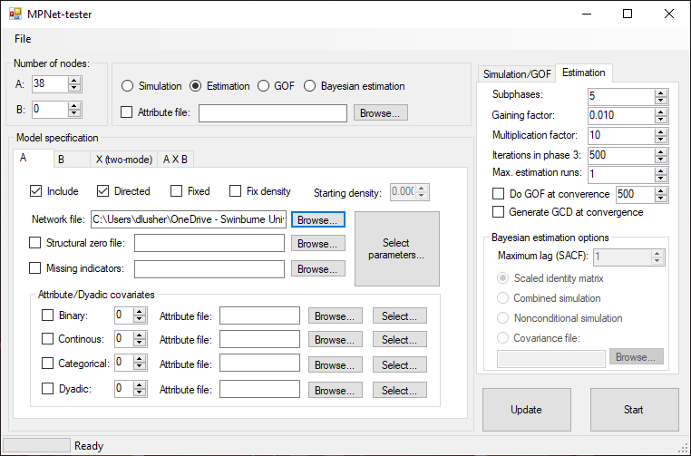

You can estimate models with a variety of attribute effects with the different types of attribute variables (binary, continuous, categorical). The common starting model specifications for directed networks would include **sender** and **receiver** effects, and **interaction**/**homophily**. Homophily can be implemented in various ways, as will be seen below.

Select Actor Attribute parameters, and indicate the numbers of attributes in each of the attribute files (one of each).

Select parameters for each of the types of attributes. Specify the file that contains the attribute variables.

* For the **binary attribute** (**seniority**), select ***sender***, ***receiver*** and “***interaction***”, a homophily variable that in this case will be 1 if both actors are senior (i.e. both score 1).
* For the **continuous** **attribute** (**projects**), select ***sender***, ***receiver*** and ***difference*** effects. For continuous variables, a popular way to implement homophily is the absolute difference between the attribute values of the sender and receiver of the tie. In that case, a **negative** parameter estimate indicates the presence of homophily.
* For the **categorical** **attribute** (**office**), select the *Matching-attribute*. This is a homophily effect that comes into play when both sender and receiver are in the same category.
  + **NB!!!!!!** For categorical variables, **Do Not** select effects for **both** Matching and Mismatch *in the same model for the same attribute*, as one is the complement of the other (and choosing both will result in the model producing degenerate results due to 100% collinearity).

The output will then include both structural and attribute parameters in the model. So, now you will:

1. Do an estimation including the actor attributes. If you have not closed MPNet from before, the structural parameters will still be there so you will not need to select them again.

Interpretation of results

From the **estimation** you should see a number of significant effects. There is a homophily effect for seniority, and also for projects (remember, a negative “difference” effect means there is little difference, hence homophily). There is also a negative sender effect for seniority, indicating that executives who are not senior (binary variable = 0) are more likely to send ties.

15.2 Dyadic covariates

You can also use a dyadic covariate measure as a predictor of network ties. An example of a dyadic covariate is another network (e.g., trust, advice, friendship) or a network of geographic distances between all pairs of people in the network.

For this example, the dataset *advice.txt* is an advice network for the 38 managers. To use this as an exogenous predictor of communication ties, in addition to the existing structural and actor attribute effects, select **Dyadic Attributes**, and then when Selecting parameters, enter the dyadic covariate file and select Covariate-Arc.

Network Data: **communication.txt**

Attribute Data: **seniority.txt**

**projects.txt**

**office.txt**

Covariate Network: **advice.txt**

**NB:** Currently in MPNet, dyadic covariates matrices need values to be separated by Tabs. Covariate matrices can contain values (e.g. strength of ties) other than binary.

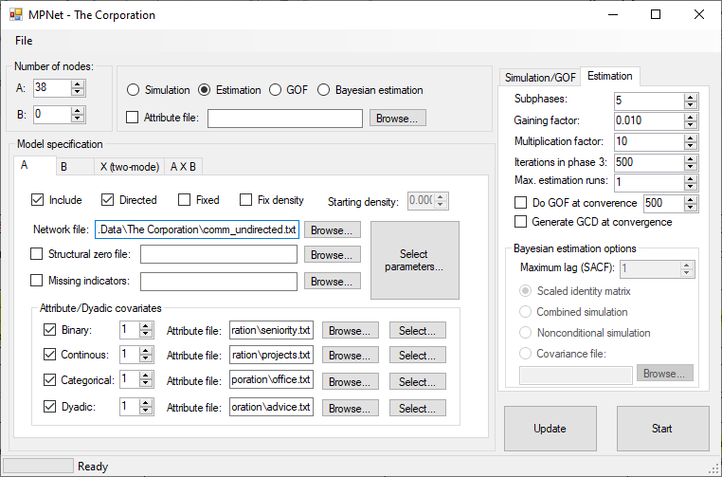

Run the estimation. In this final model, you should see that various structural, actor attribute and dyadic covariate effects all play a role in explaining the structure of the communication network.

There is a very strong and significant effect for the covariate network “advice” which indicates that communication links are very likely associated with advice.